COVID-19 response: Soap making from plant oil
Using soap for hand washing is extremely important to help preventing the spreading of diseases like caused by COVID-19. When there is shortage of soap it can be made by households in rather simple ways. Some sources are described hereafter.
Major ingredients for making soap are plant oil and lye.
Almost any oil can be used to make soap, in practice most oils used are: olive- and palm-oil, coconut-, sunflower-, groundnut-, but also oils from neem, jatropha, castor, moringa, etc
Potash (Potassium ash) can be made from ash of hardwood or plants that contain Potassium like banana peels, cacao pods, tamarind pods, etc. Plants are dried, roasted and ground into a powder. Potassium is also found in mines as a mineral and is also called Potash.
Lye is then made by dissolving Potash (or caustic soda) in water, according a certain ratio.
A Forum on Soap making can be found at : https://www.soapmakingforum.com/
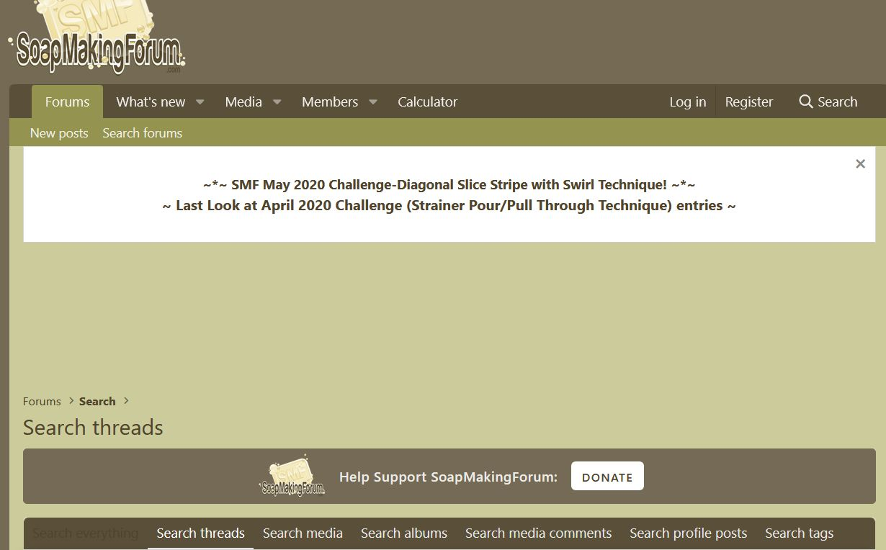
It has a rather complete overview of all possible oils used to make soap, plus a calculation tool for determining the right ratio of the ingredients, like oil, water, lye and eventual additives for smell or colour.
Another source in which recipes for making soap at house hold level are described is the Smart-Hygiene-Solutions booklet, see: http://smartcentregroup.com/wp-content/uploads/2020/05/Smart-Hygiene-Solutions_V2.1_04MAY2020_LQ.pdf .

Soap from oil containing seeds
One of the simplest methods to make soap at house hold level is to make soap from grinded seeds, that contain oil. No oil is required then, the only ingredients are seeds, potash and water.
Seeds from Castor, Palm, Neem, Jatropha and Shea nuts are being used to make soap this way, but probably many more types of seeds are being used.
Be careful: oil from castor and jatropha are poisonous.
Potash (Potassium ash) can be made from ash of hardwood or plants that contain potassium like banana peels, cacao pods, tamarind pods, etc. Plants are dried, roasted and ground into a powder.
The following example recipe of soap from grinded jatropha kernel (the core of the seed) is derived from the FACT Jatropha Handbook, Annex D5: https://www.bioenergyforumfact.org/reports/fact-jatropha-handbook
Recipe for making soap from oil containing seeds:
Materials needed | Ratio
Milled jatropha kernel | 100
Clean dry ash, from wood or plants | 50
Water | 20
3 Pans
A Cloth
Fire place
Optional: other oils or animal fats

First: making lye
- Heat up a pan with (preferably rain-) water; it is not necessary to boil it, but it should be quite hot.
- Place a cloth on top of the opening of another iron or stainless steel pan (not aluminum or copper!!) and fill the cloth with ash.
- Slowly pour the hot water on the ash in the cloth; the water is being filtered through the
cloth while absorbing the potash in the water. This abstracted water is lye. The lye should be quite strong. The strength can be increased by boiling the lye for about three hours to evaporate water and increase its concentration. The strength can be tested by putting an egg or potato in the pan. When it floats the concentration is good.
Be careful; the fumes of boiling are dangerous!!
Be careful; Lye is very aggressive so protect eyes and skin

Recipes for making lye using potash and water are given in both documents from the links mentioned above.

Second: making soap
- Put the grinded/milled jatropha kernel in a pan and put it on a low fire.
- If desired other types of fats can be added to the jatropha kernel.
- Slowly add the lye to the jatropha kernel.
- Mix slowly.
- The jatropha kernel will slowly absorb the lye. Keep on adding the lye until the fats are totally converted. This process requires patience and should be done on a low fire.
- After it gets a more solid form, balls can be made.
- After three days these balls are ready to use.
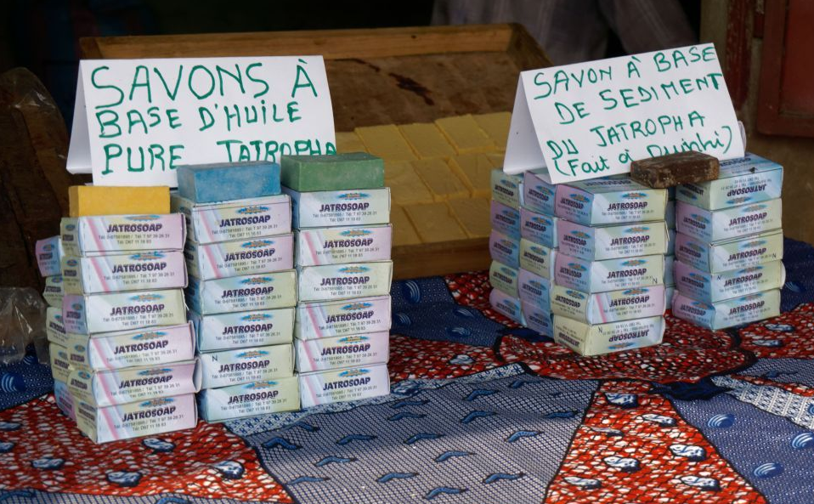
Soap made from Jatropha oil (left) and from Jatropha press cake (right) on the market in Benin (2018) (Source: Evaluation Report Jatropha Project Benin, Janske van Eijck et al, 2014: https://www.bioenergyforumfact.org/sites/default/files/2018-04/Evaluation%20report%20Jatropha%20project%20Benin%20final%2002_10_2014.pdf

